eFolio – Week 3 and 4
  - Naveen Sellathurai – 33106770

eFolio Task 3.1
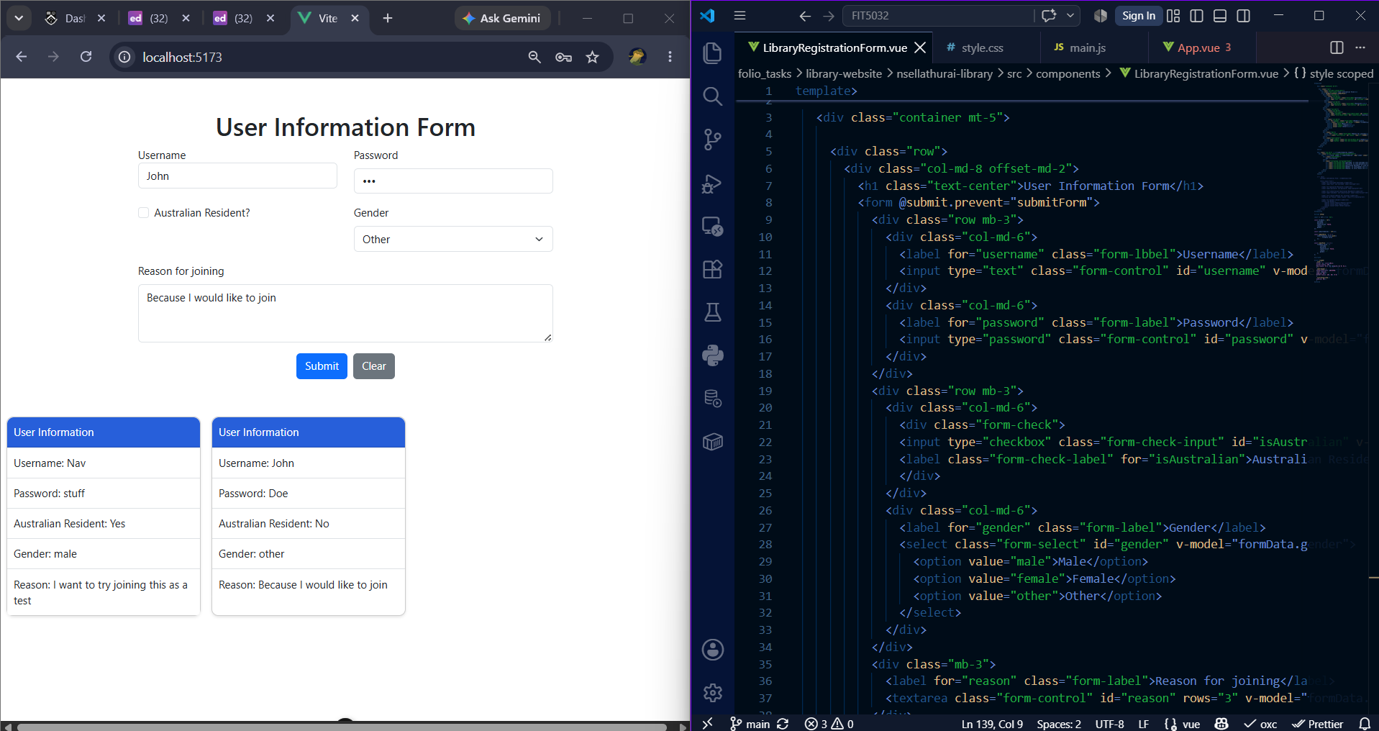

eFolio Task 4.1
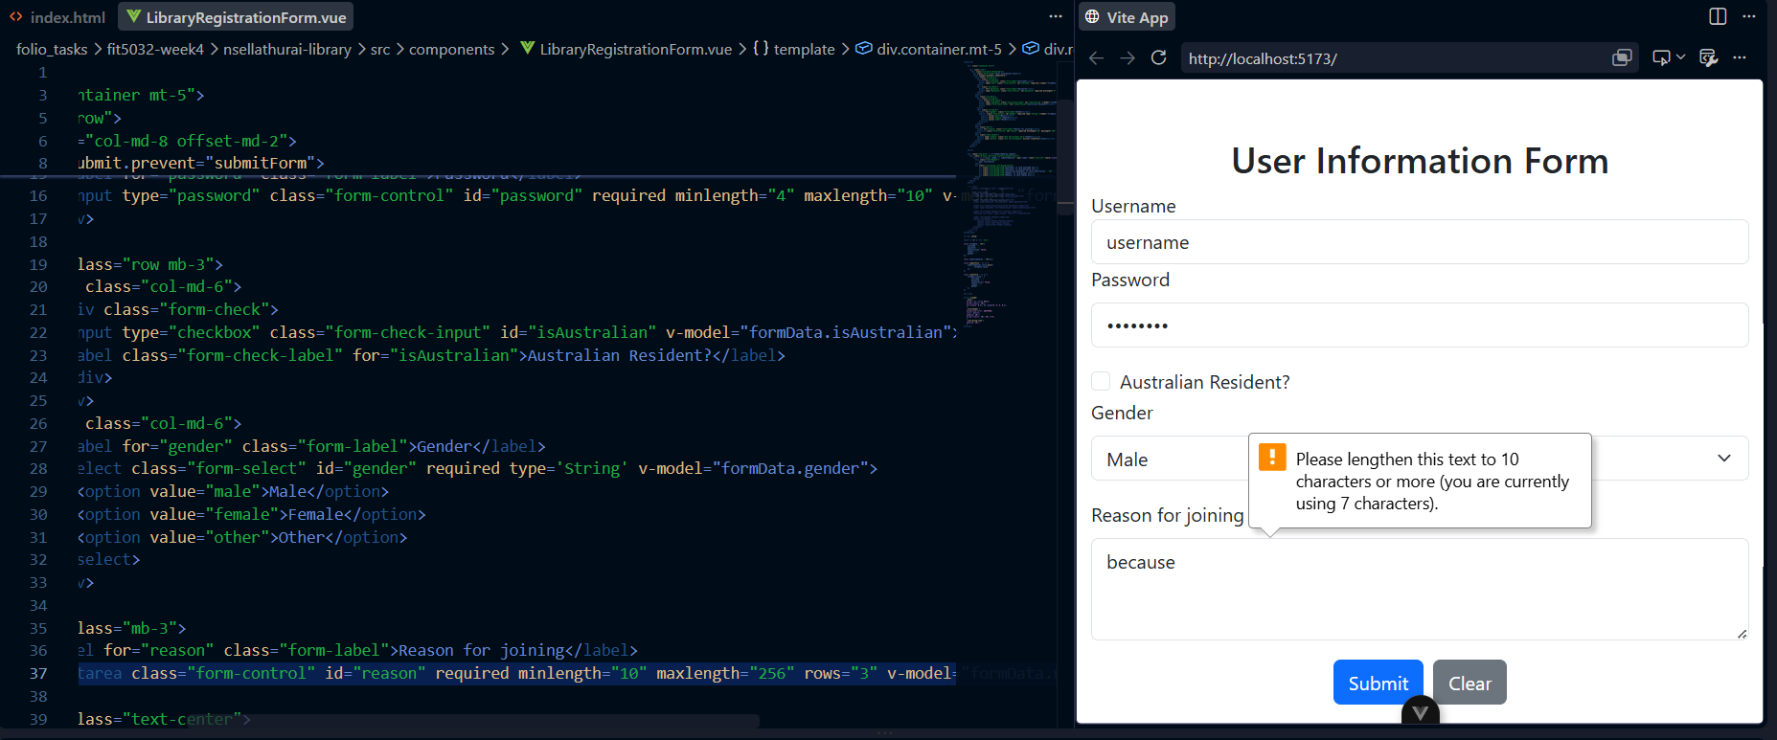

eFolio Task 4.2
